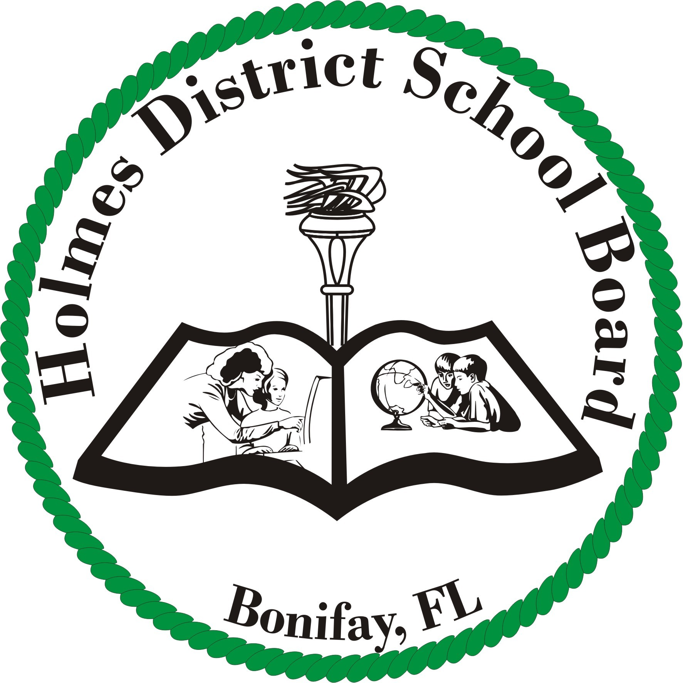
Holmes District School Board
701 Pennsylvania Avenue
Bonifay, FL 32425

TO: HOLMES COUNTY SCHOOL BOARD
FROM:

DATE:

RE: RESIGNATION FROM EMPLOYMENT
I, , do hereby resign from my position as with the Holmes County School Board effective , at ( A.M./ P.M.).
Reason for resignation: (Check One)
A Retirement
B Resignation for employment in education in Florida
C Resignation for employment outside of education
D Resignation with prejudice
E Resignation for personal reasons
F Staff reduction
G Dismissal due to findings by the board related to charges
H Death
I Contract Expired
J Reason not given
K Disabled
L Resignation for employment in education outside Florida
M Contract not renewed, due to less than satisfactory performance
N Dismissed during probationary period

Employee Signature Supervisor Signature Superintendent Signature

Date Date Date

Revised December 2009

