Holmes School District
21st CCLC WINGS Grant

Mid-Year Formative Report

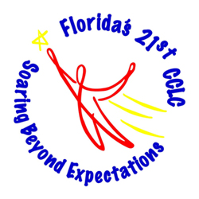

Prepared By
Sheri Brooks
21st CCLS WINGS Grant Evaluator

Holmes District
Mid-Year Report
Percentage of Students Who Met Goal

Elementary – 255 Students
Middle – 56 Students
English/Language Arts - 80% of participating students will maintain an A/B grade or improve from a grade of C to B or a grade of D/F to C (or grading scale equivalents)
Elementary – 61%
Middle – 61%

Mathematics - 80% of participating students will maintain an A/B grade or improve from a grade of C to B or a grade of D/F to C (or grading scale equivalents)
Elementary – 67%
Middle – 52%

Science - 80% of participating students will maintain an A/B grade or improve from a grade of C to B or a grade of D/F to C (or grading scale equivalents)
Elementary – 83%
Middle – 66%

Character - 80% of participating students will increase their application of positive character traits as measured by pre-post assessment.
Elementary – 64%
Middle – 68%

Nutrition- 80% of participating students will increase their health knowledge as measured by pre-post assessment.
Elementary – 65%
Middle – 67%

Improve Literacy- 70% of participating students will improve their literacy skills as measured by perceptual survey (parent).
Elementary – 100%
Middle – 100%

Improve Involvement in Student Education - 70% of participating family members will demonstrate their involvement in student education as measured by logs.
Elementary – 42%
Middle – 20%

